

**Signs with Smart Connectivity for Better Road Safety**

**A MINI PROJECT REPORT**

***Submitted by***

**SNEHA P** **(AC19UCS109)**

**SWAPNA V** **(AC19UCS123)**

**SWITHIN ASIR S (AC19UCS125)**

**THEJESHKUMAR S (AC19UCS129)**

***in partial fulfilment for the award of the degree***

***of***

**BACHELOR OF ENGINEERING**

***in***

**COMPUTER SCIENCE AND ENGINEERING**

**ADHIYAMAAN COLLEGE OF ENGINEERING**

DR. M.G.R NAGAR, HOSUR-635130

**ANNA UNIVERSITY: CHENNAI 600 025**

**OCTOBER 2021**



**Signs with Smart Connectivity for Better Road Safety**

**A MINI PROJECT REPORT**

***Submitted by***

**SNEHA P** **(AC19UCS109)**

**SWAPNA V** **(AC19UCS123)**

**SWITHIN ASIR S (AC19UCS125)**

**THEJESHKUMAR S (AC19UCS129)**

***in partial fulfilment for the award of the degree***

***of***

**B ACHELOR OF ENGINEERING**

***in***

**COMPUTER SCIENCE AND ENGINEERING**

**ADHIYAMAAN COLLEGE OF ENGINEERING**

DR. M.G.R NAGAR, HOSUR-635130

**ANNA UNIVERSITY: CHENNAI 600 025**

**OCTOBER 2021**

**ANNA UNIVERSITY: CHENNAI 600 025**

**BONAFIDE CERTIFICATE**

Certified that this mini project report **“Signs with Smart Connectivity for Better Road Safety”** is the bonafide work of **“SNEHA P(AC19UCS109), SWAPNA V(AC19UCS123), SWITHIN ASIR S(AC19UCS125), THEJESHKUMAR S(AC19UCS129)”** who carried out the projectunder my supervision.

**SIGNATURE** **SIGNATURE**

**Dr. G. FATHIMA, M.E., Ph.D.,** **Mrs.B.Revathi M.E.,**

**HEAD OF THE DEPARTMENT** **SUPERVISOR**

**PROFESSOR, ASSISTANT PROFESSOR,**

Department of CSE, Department of CSE,

Adhiyamaan College of Engineering, Adhiyamaan College of Engineering,

(Autonomous) (Autonomous)

Dr. M.G.R. Nagar, Dr. M.G.R. Nagar,

Hosur – 635 130. Hosur – 635 130.

Submitted for the Mini project VIVA-VOCE Examination held on ________________ at **Adhiyamaan College of Engineering (Autonomous), Hosur-635 130.**

**INTERNAL EXAMINER** **EXTERNAL EXAMINER**

**ACKNOWLEDGEMENT**

It is one of the most efficient tasks in life to choose the appropriate words to express one’s gratitude to the beneficiaries. We are very much grateful to God who helped us all the way through the project and how moulded us into what we are today.

We are grateful to our beloved Principal **Dr. G. RANGANATH, M.E., Ph.D.,** Adhiyamaan College of Engineering (Autonomous), Hosur for providing the opportunity to do this work in premises.

We acknowledge our heartful gratitude to **Dr. G. FATHIMA, M.E., Ph.D.,** Professor and Head of the Department, Department of Computer Science and Engineering, Adhiyamaan College of Engineering (Autonomous), Hosur, for her guidance and valuable suggestions and encouragement throughout this project.

We are highly indebted to **Mrs.B.Revathi M.E.,** Assistant Professor, Department of Computer Science and Engineering, Adhiyamaan College of Engineering (Autonomous), Hosur, whose immense support, encouragement and valuable guidance made us to complete this project successfully.

We also extent our thanks to Project Coordinator and all Staff Members for their support in complete this project successfully.

Finally, we would like to thank to our parents, without their motivational and support would not have been possible for us to complete this project successfully.

Signs with Smart Connectivity for Better Road Safety

TEAM ID- PNT2022TMID08042

CONTENTS

**1. INTRODUCTION**

1.1 Project Overview

1.2 Purpose

**2. LITERATURE SURVEY**

2.1 Existing problem

2.2 References

2.3 Problem Statement Definition

**3. IDEATION & PROPOSED SOLUTION**

3.1 Empathy Map Canvas

3.2 Ideation & Brainstorming

3.3 Proposed Solution

3.4 Problem Solution fit

**4. REQUIREMENT ANALYSIS**

4.1 Functional requirement

4.2 Non-Functional requirements

**5. PROJECT DESIGN**

5.1 Data Flow Diagrams

5.2 Solution & Technical Architecture

5.3 User Stories

**6. PROJECT PLANNING & SCHEDULING**

6.1 Sprint Planning & Estimation

6.2 Sprint Delivery Schedule

6.3 Reports from JIRA

**7. CODING & SOLUTIONING (Explain the features added in the project along with code)**

7.1 Feature 1

7.2 Feature 2

7.3 Database Schema (if Applicable)

**8. TESTING**

8.1 Test Cases

8.2 User Acceptance Testing

**9. RESULTS**

9.1 Performance Metrics

**10. ADVANTAGES & DISADVANTAGES**

**11. CONCLUSION**

**12. FUTURE SCOPE**

**13. APPENDIX**

Source Code

GitHub & Project Demo Link

CHAPTER 1

INTRODUCTION

**1.1 INTRODUCTION**

**PROJECT OVERVIEW**

Connected vehicle technology aim to solve some of the biggest challenges in the transportation in the areas of safety, mobility and environment. The safety application for Intelligent Transport System (ITS) is one of the main objectives in this project. Safety application is research and industrial initiative which aim to contribute to the global advancement of automobile industry. In this project wefocus on V2V communication, once cars are connected which is able to share data with other cars on the road and which help to reduce Highway accidents. Ultimately, vehicles are connect via multiple complementary technologies of vehicle to-vehicle (V2V) and vehicle-to-infrastructure (V2I) connectivity based on Wi-Fi, GPS, Dedicated Short Range Communication (DSRC). VANETS are also considered as one of the most important Simulator for safety of intelligent transportation systems. The use of the DSRC technologies support low latency vehicle-to-vehicle (V2V) communication. Inpresent Systems the road signs and the speed limits are static. But the road signs can be changed in some cases. We can consider some cases when there are some road diversions due to heavy traffic or due to accidents then we can change the road signs accordingly if they are digitalized. This project proposes a system which has digital sign boards on which the signs can be changed dynamically. If there is rainfall then the roads will be slippery and the speed limit would be decreased. There is a web app through which you can enter the data of the road diversions, accident prone areas and the information sign boards can be entered through web app. This data is retrieved and displayed on the sign boards accordingly. Clearly, intelligent roadway placards can be a vital part of our driving experience. They enable a better way for drivers to access the information they need in real time on the roads. These signs can increase awareness of upcoming issues, which people might otherwise discover too late. They may also augment the functionality of driverless vehicles.

**Purpose:**

The value of implementing this technology should not be underestimated. Smart roadway indicators have the potential to increase cost-efficiency, which eases the burden on governments and taxpayers.They facilitate a smoother driving process for both human drivers and autonomous vehicles. The placards can be more user-friendly than the analog route signs we currently employ. Above all, they may ultimately lead to a safer network of roads for everyone. Smart roadway signage is not simply an objective for the future. Two UK Companies have collaborated to produce these signs for use on England’s roads. The signs are technologically advanced, with graphics and text that drivers can see clearly. The messages are easy to comprehendquickly, keeping drivers informed of route conditions as they change. In addition to enhancing theroadway experience for users, this new signage costs less to maintain than traditional indicators. The new signs require fewer materials and less cabling, resulting in less time, upkeep, and expense. Increasing volumes of traffic are using municipal road infrastructure, with severe consequences fortraffic efficiency and the safety of road users. Vulnerable roads users (VRUs), such as pedestrians or cyclists, are involved in 46 % of lethal accidents. Exchanging information between road users increases their perception and is thus a critical building block to improve this situation. We have presented a system, to alert the driver about the speed limits in specific areas and reduce the speed of the vehicles in sensitive public zones without any interference of the drivers where controls are takenautomatically by the use of a wireless local area networks.

**LITERATURE:**

**EXISTING PROBLEM:**

The Existing road system and connectivity, emphasis on the traffic and route reckoning features which cordially provisions the user acceptability to have better connectivity management. But, this often results in nonparallel road conditions and high noise ratios through the calibrations. It reiterates various subjections in its compilation and leading to segmentation error throughout. It penetrates the various unit cases in order to subsequently manifest the output. This alternatively symbolizes the ineffectively programmed web user interface. The IOT based model of our project complies of the verdict to specify the soft zone in the path. It manually ask the user to turn off the horn, which in variably decreases the decibel level of the power output. Illustratively, it confides the work schematics of the precedent evaluation under the system and allows the user to access the terminals of the app nodes variably. IBM Cloud indefinitely helps in reviving the data sets required in web application. MIT app inventor segments the creation of the user interface

**REFERENCES:**

1. Ashish Dhar: **Traffic and road condition monitoring system**

Indian Institute of Technology, Mumbai. - 2008.

•Reports severity, intensity and dimension of a damaged road segment.

• Proposed a different solution using AMR Magnetic Sensor.

2. Pooja Pawar, Suvarna Langade, Mohini Bandgar**: IOT Based digital Notice Board using Arduino ATMega 328.**

International Research Journal of Engineering and Technology(IRJET).- 2019.

•Circulates notice regularly & reduce physical efforts.

• Send message at any distant location within a second.

3. Sandeep Chaware, Trushitha Chaware: **Proposed Algorithm for Smart Traffic Control using Ultrasonic Sensor.**

International Journal of Engineering and Advanced Technology (IJEAT).- 2019.

•The outcome of the project is to learn insights of the traffic controlling and management at

the signal with the dynamically changing in timing of timer as per need.

4. KamnaSingh, Deepa Bura**: IOT distinct algorithms for the Sensor Connectivity with Comparative Study between node MCU and Arduino MCU.**

NVEO Journal– 2021

• Presents different algorithms for the connection between different types of sensors.

•Brief description of node MCU & Arduino MCU.

• Step by step solution to provide connectivity with IOT technology.

5. Jack Greenhaigh: **Recognizing Text Based Traffic Signs.**

IEEE – 2015

• Detect all possible Road sign candidates.

•Reduce total regions based on contextual constraints.

• A Novel System for the automatic detection and recognition of text in traffic sign based on MSER & MSV.

6. Bhumika.R, Harshita. S.A, Meena. D, Asha. N: **Accident Prevention and Road Safety in Hilly Region using IOT Module**

International Research Journal of Engineering and Technology (IRJET) – 2021

• Stay away from mishap & forestall clog in sloping region & hairclip twist.

• As a significant part of street mathematical plan bended street portion

7. Sowparnika: **IOT Road Safety**

•This project paves a system to alert the driver about the speed limit in specific areas and to

reduce the speed of vehicles in sensitive public zones without any interference of drivers where

controls are taken automatically by use of wireless local area network.

8. S.S. Sugania, D. S. Vishalis Hwaran, J. Vignesh Kumar: **Automated System for Road Safety Enhancement using big data reports.**

• The speed is controlled accordingly to situations to give suggestions.

• The suggested system can control the vehicle but at same time can collect data and

manipulate it using the big data technologies.

9**. IOT Based Smart Road Safety & Vehicle Accident prevent System for Mountain roads**.

•This system is divided into 2 half (Accident Detection & Prevention) and alerting the members of family by causation message and placement of accidental place.

10. Shweta Vyas, Pooja Awhale, Shreya Kukdeja, Prashant Jawalkar: **A Modern Approach to identify Traffic Sign Symbols in Color Images.**

•In this technique proposed more reliable and robust method of Traffic Sign Detection Recognition (TSDR).

**PROBLEM STATEMENT DEFINITION:**

To replace the static signboards with smart connected sign boards to get the speed limitations from a web app using weather API and update it automatically based on the weather conditions, set diversions through API and warn drivers for school zones and hospital zones.

**IDEATION AND PROPOSED SOLUTION :**

**EMPATHY MAP CANVAS**

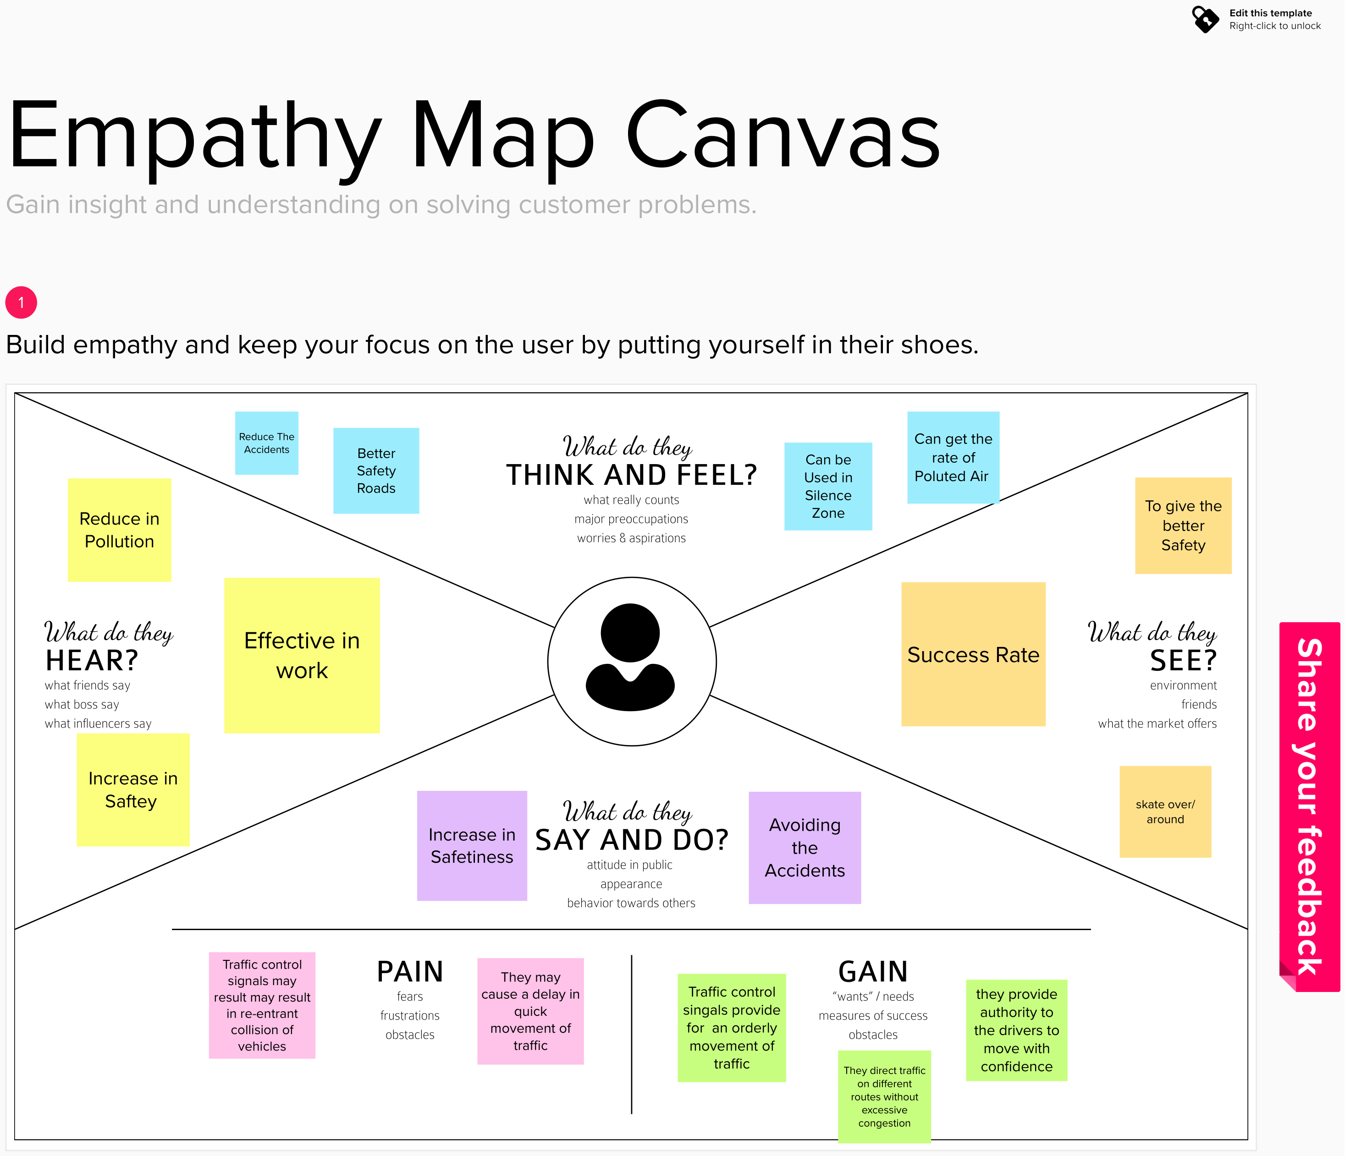

**Ideation & Brainstorming:**

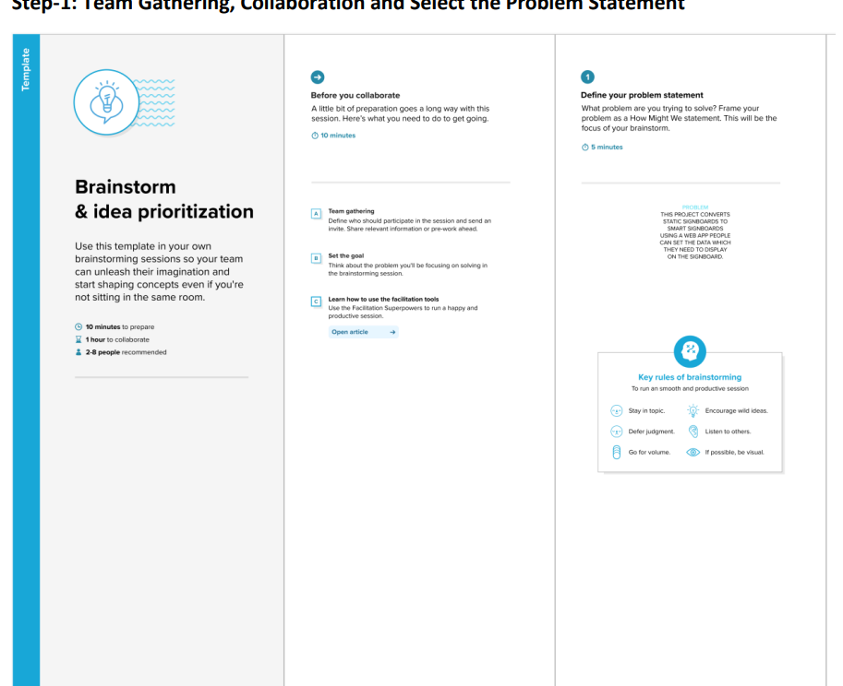

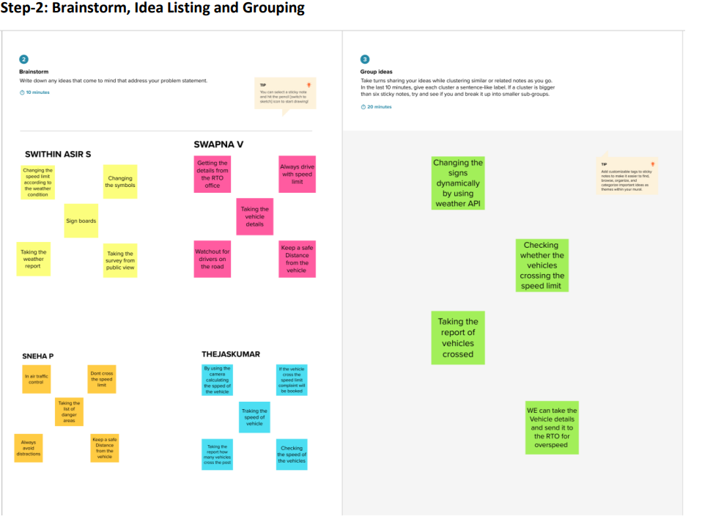

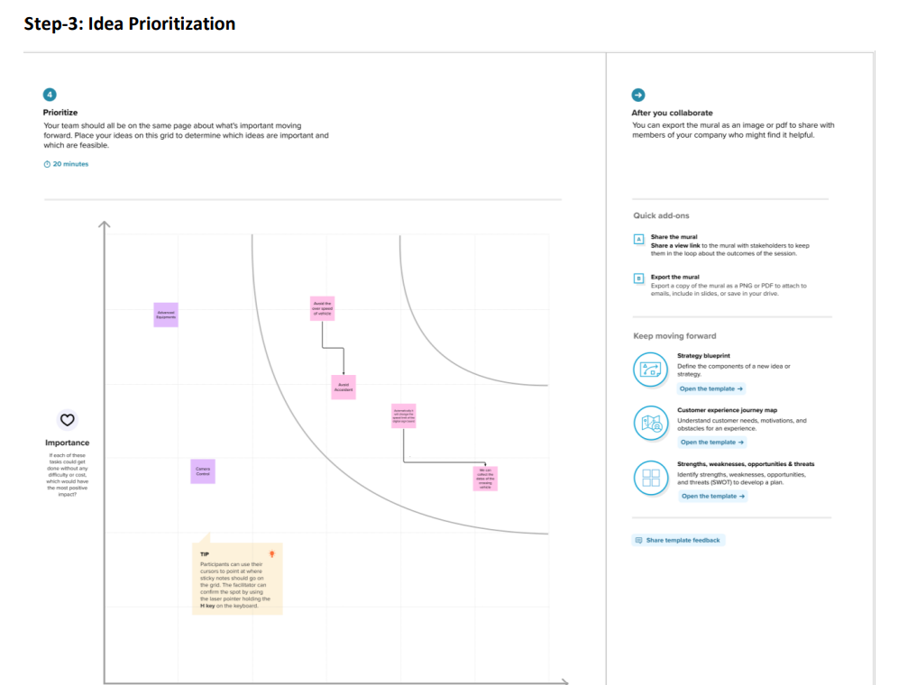

**Proposed Solution:**

|  |  |  |
| --- | --- | --- |
| **S.No.** | **Parameter** | **Description** |
|  | Problem Statement (Problem to be solved) | Avoid the over speed and to decrease the accidents |
|  | Idea / Solution description | * TO REPLACE THE STATIC SIGNBOARDS, SMART CONNECTED SIGN BOARDS ARE USED. * THESE SMART CONNECTED SIGN BOARDS GET THE SPEED LIMITATIONS FROM A WEB APP USING WEATHER API AND UPDATE AUTOMATICALLY. * BASED ON THE WEATHER CHANGES THE SPEED MAY INCREASE OR DECREASE. * BASED ON THE TRAFFIC AND FATAL SITUATIONS THE DIVERSION SIGNS ARE DISPLAYED. * GUIDE(SCHOOLS), WARNING AND SERVICE(HOSPITALS, RESTAURANT) SIGNS ARE ALSO DISPLAYED ACCORDINGLY. * DIFFERENT MODES OF OPERATIONS CAN BE SELECTED WITH THE HELP OF BUTTONS. |
|  | Novelty / Uniqueness | Sign boards are converted to digitals |
|  | Social Impact / Customer Satisfaction | Reduce the accidents , Control the vehicles in speed |
|  | Business Model (Revenue Model) | In this we can get good no of users ,so that the business can get profit |
|  | Scalability of the Solution | We can scalable the project by schools and colleges as our customer |

**Problem Solution fit:**

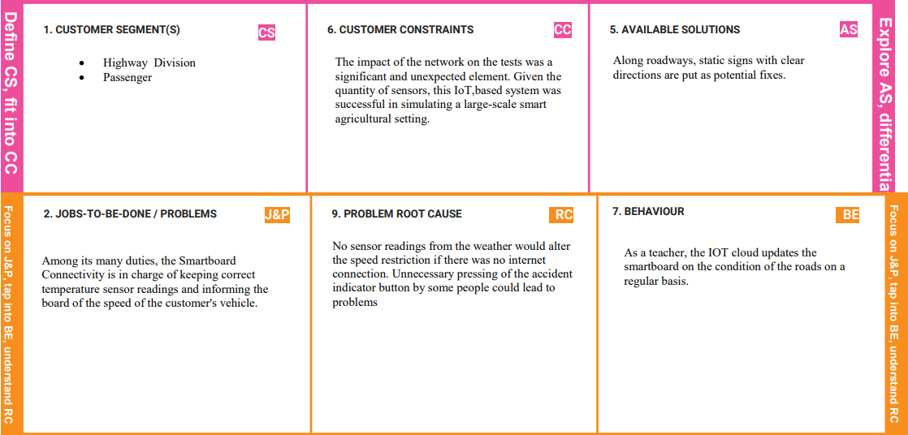

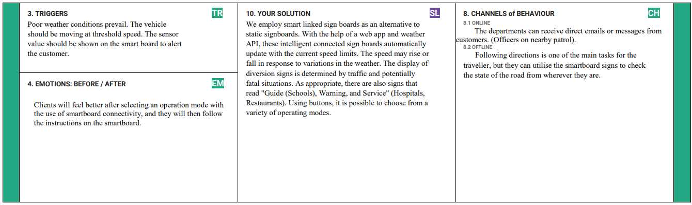

**REQUIREMENT ANALYSIS:**

**Functional Requirements:**

|  |  |  |
| --- | --- | --- |
| **FR No.** | **Functional Requirement (Epic)** | **Sub Requirement (Story / Sub-Task)** |
| FR-1 | User Registration | Sign boards should be made with LEDs that are brightly coloured and capable of attracting the attention of drivers, but they should not be too distracting or blinding as this may lead to accidents. |
| FR-2 | User Understanding | The signs should be large, clear, and legible in order for the motorist to comprehend them, and they can also incorporate images. |
| FR-3 | User Convenience | The signs should be large, clear, and legible in order for the motorist to comprehend them, and they can also incorporate images. |

**Non-functional Requirements:**

|  |  |  |
| --- | --- | --- |
| **FR No.** | **Non-Functional Requirement** | **Description** |
| NFR-1 | **Usability** | When necessary, it should be able to upgrade and update. |
| NFR-2 | **Security** | When necessary, it should be able to upgrade and update. |
| NFR-3 | **Reliability** | It should be able to show information appropriately and without errors. |
| NFR-4 | **Performance** | It should be able to update itself automatically when a weather or traffic problem happens. |
| NFR-5 | **Availability** | It should be accessible 24 hours a day, seven days a week in order to benefit the consumer, i.e. the driver. |
| NFR-6 | **Scalability** | It should be simple to update and upgrade in response to changes in the requirements. |

**PROJECT DESIGN:**

**Data Flow Diagrams:**

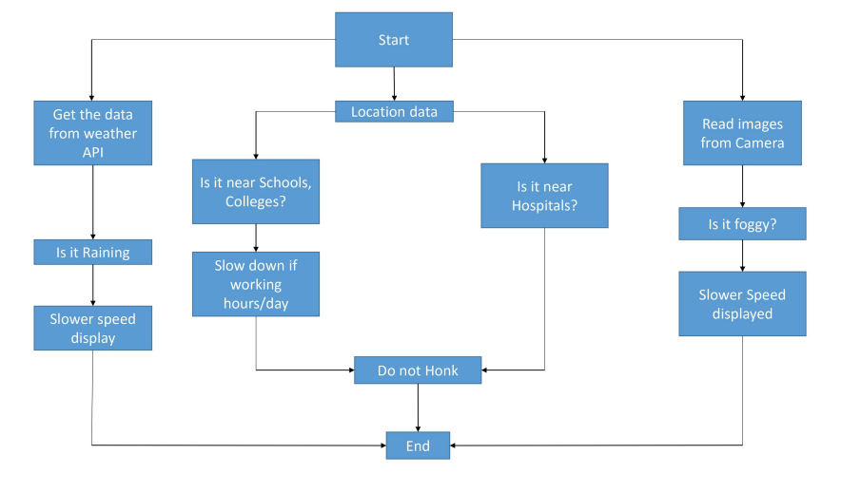

**Solution & Technical Architecture:**

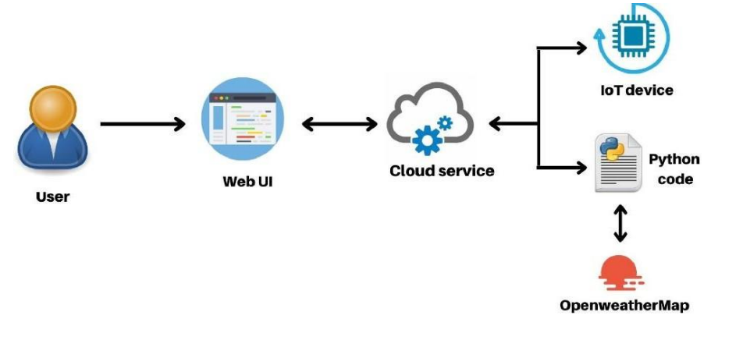

**TECHNICAL ARCHITECTURE:**

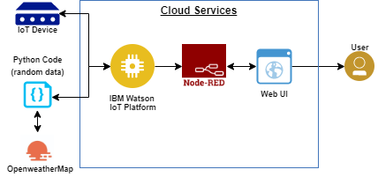

**User Stories:**

| **User Type** | **Functional Requirement (Epic)** | **User Story Number** | **User Story / Task** | **Acceptance criteria** | **Priority** | **Release** |
| --- | --- | --- | --- | --- | --- | --- |
| Customer (Mobile user) | Registration | USN-1 | I may use a climate programme to determine my speed limit, | I may obtain speed limits. | High | Sprint-1 |
|  |  | USN-2 | I may sign up for the application as a client by entering my email, my secret phrase, and verifying my secret phrase. | I can access my dashboard and account. | Medium | Sprint-2 |
|  |  | USN-3 | As a customer, I am free to increase or decrease my speed in response to changing weather circumstances. | I am able to increase or decrease my speed. | High | Sprint-1 |
|  |  | USN-4 | As a customer. Depending on the flow of traffic and the potentially fatal situations, I may at any time get my traffic redirection signals | I can access my traffic situation while moving forward. | Medium | Sprint-1 |
|  | Login | USN-5 | I may log out of the dark climate map as a client by inputting my email and secret key | I can access the programme using my Gmail login. | High | Sprint- 2 |
|  | Dashboard | USN-6 | The connection point should be clear and functional for the client. | I have no trouble getting to the point of interaction. | High | Sprint-1 |
| Customer (Web user) | Data generation | USN-7 | As a customer, I use the open climate application to get information on changes in the weather. | Through the programme, I may get information on the climate | High | Sprint-1 |
| Administrator | Problem solving/ Fault clearance | USN-8 | As an in-charge for the proper operation of the sign sheets, you must occasionally observe it to stay on top of it. | The sign sheets can be checked by authorities for genuine employment. | Medium | Sprint-2 |

**PROJECT PLANNING & SCHEDULING:**

**Sprint Planning & Estimation**

|  |  |  |  |  |
| --- | --- | --- | --- | --- |
| Sprint | Functional Requirement (Epic) | User Story / Task | Story Points | Priority |
| Sprint-1 | Resources Initialization | Create and initialize accounts in various public APIs like Open Weather API. | 1 | LOW |
| Sprint-1 | Local Server/Software Run | Write a Python program that outputs results given the inputs like weather and location. | 1 | MEDIUM |
| Sprint-2 | Push the server/software to cloud | Push the code from Sprint 1 to cloud so it can be accessed from anywhere | 2 | MEDIUM |
| Sprint-3 | Hardware initialization | Integrate the hardware to be able to access the cloud functions and provide inputs to the same. | 2 | HIGH |
| Sprint-4 | UI/UX Optimization & Debugging | Optimize all the shortcomings and provide better user experience. | 2 | LOW |

**Sprint Delivery Schedule:**

|  |  |  |  |  |  |
| --- | --- | --- | --- | --- | --- |
| Sprint | Total story points | Duration | Sprint Start date | Sprint end date | Story Points Complete |
| Sprint-1 | 20 | 6 | 24 oct 2022 | 19 Nov 2022 | 20 |
| Sprint-2 | 20 | 6 | 05 Nov 2022 | 19 Nov 2022 | 20 |
| Sprint-3 | 20 | 6 | 07 Nov 2022 | 19 Nov 2022 | 20 |
| Sprint-4 | 20 | 6 | 14 Nov 2022 | 19 Nov 2022 | 20 |

**Reports from JIRA:**

**Burndown Chart:**

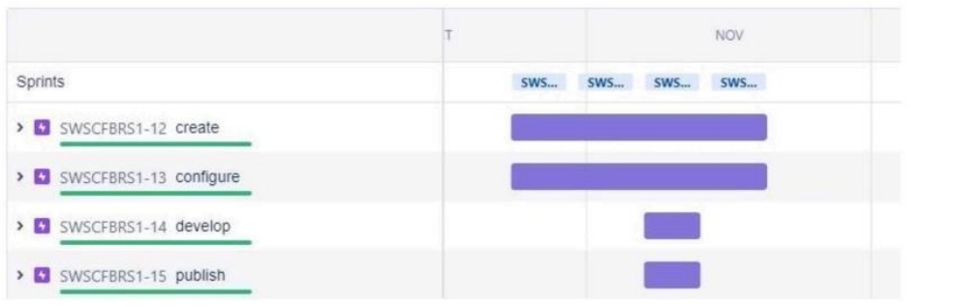

**7.CODING & SOLUTIONING (Explain the features added in the project along with code):**

**PROGRAM CODE :**

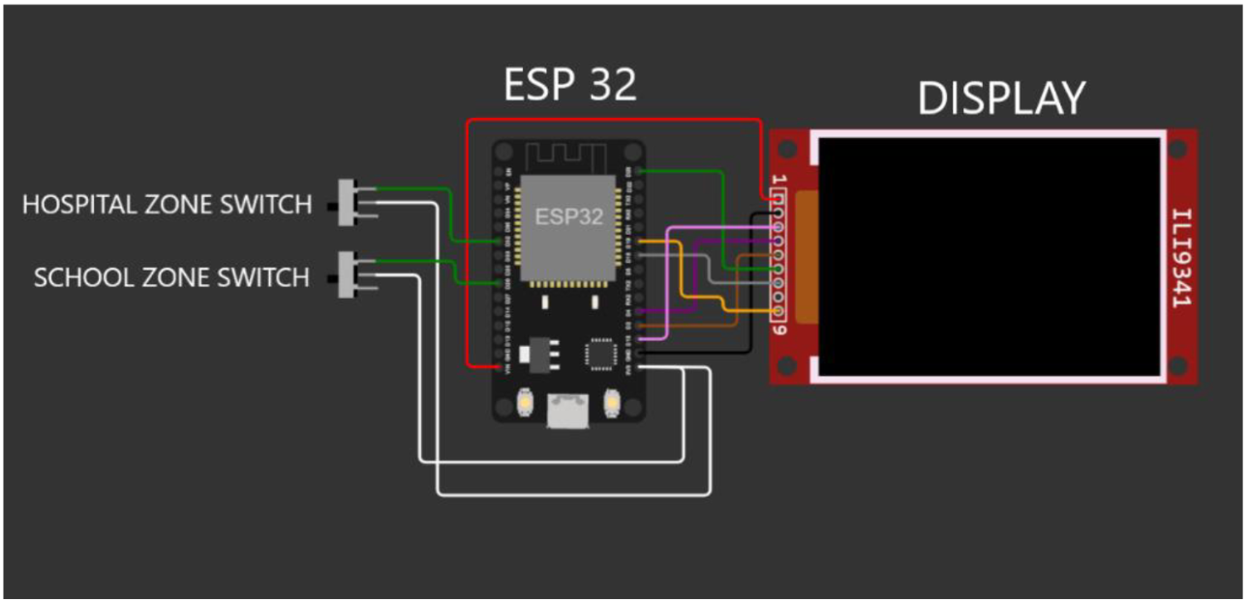

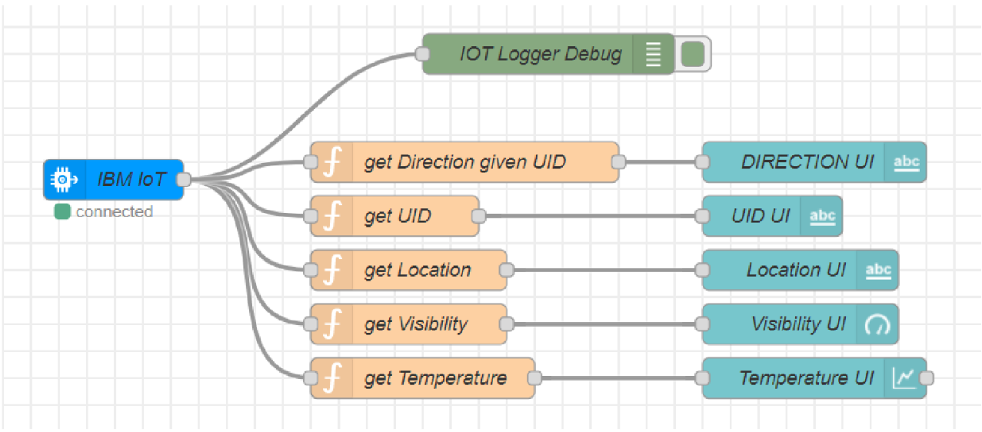

There are 3 flows in the above Node RED flow.

They are Node RED UI flow

/getSpeed API flow

/setDirection API flow

1. **Node RED UI flow :**

UI FLOW

"IBM IOT" node connects the backend to Node RED UI

The function nodes such as "get Direction given UID", "get UID", "get Location", "get Visibility" &

"get Temperature" extract the respective data out and provides them to the UI nodes "Direction UI","UID UI", "Location UI", "Visibility UI" & "Temperature UI".

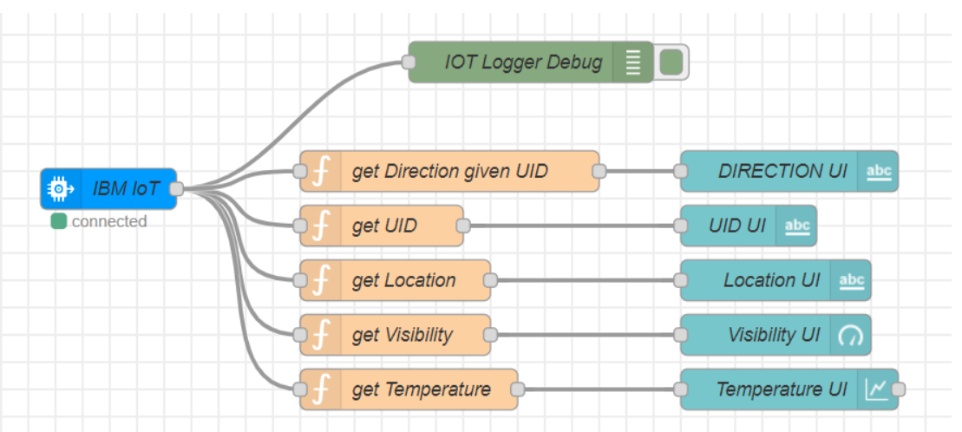

// get Direction given UID

msg.payload = global.get(String(msg.payload.uid));

return msg;

// get UID

msg.payload = msg.payload.uid;

return msg;

// get Location

msg.payload = msg.payload.location;

return msg;

// get Visibility

msg.payload = msg.payload.visibility;

return msg;

// get Temperature

msg.payload = msg.payload.temperature;

return msg;

"IOT Logger Debug" node logs the data at debugger.

2. /getSpeed API flow :

getSpeedAPI

"getSpeed In" node is an http end point. It accepts parameters like microcontroller UID, location,school & hospital zones info."Message Parser" node parses the data and passes on only required information to the next node

global.set("data",msg.payload);

msg.payload.q = msg.payload.location;

msg.payload.appid = "bf4a8d480ee05c00952bf65b78ae826b";

return msg;

"OpenWeatherAPI" node is a http request node which calls the OpenWeather API and send the data to the next node.

"Log Parser" node extracts specific parameters from the weather data and and sends it to the next node.

weatherObj = JSON.parse(JSON.stringify(msg.payload));

localityObj = global.get("data");

var suggestedSpeedPercentage = 100;

var preciseObject = {

temperature : weatherObj.main.temp - 273.15,

location : localityObj.location,

visibility : weatherObj.visibility/100,

uid : localityObj.uid,

direction : global.get("direction")

};

msg.payload = preciseObject;

return msg;

"IBM IoT" node here (IBM IoT OUT)connects the "IBM IoT" node (IBM IoT IN) mentioned in the Node-RED UI flow which enables UI updation and logging.

"Decision Maker" node processes the weather data and other information from the micro controller to form the string that is to be displayed at the Sign Board

weatherObj = JSON.parse(JSON.stringify(msg.payload));

localityObj = global.get("data");

var suggestedSpeedPercentage = 100;

var preciseObject = {

temperature : weatherObj.main.temp - 273.15,

weather : weatherObj.weather.map(x=>x.id).filter(code => code<700),

visibility : weatherObj.visibility/100

};

if(preciseObject.visibility<=40)

suggestedSpeedPercentage -=30

switch(String(preciseObject.weather)[-1]) //https://openweathermap.org/weather-conditions refer

weather codes meaning here

{

case "0" : suggestedSpeedPercentage -=10;break;

case "1" : suggestedSpeedPercentage -=20;break;

case "2" : suggestedSpeedPercentage -=30;break;

}

msg.payload = preciseObject;

var doNotHonk = 0;

if(localityObj.hospitalZone=="1"||localityObj.schoolZone=="1")

doNotHonk = 1;

var returnObject = {

suggestedSpeed : localityObj.usualSpeedLimit*(suggestedSpeedPercentage/100),

doNotHonk : doNotHonk

}

msg.payload = String(returnObject.suggestedSpeed) + " kmph \n\n" +

(returnObject.doNotHonk==1?"Do Not Honk":"") + "$" global.get(String(localityObj.uid));

return msg;

"getSpeed Out" node returns a http response for the request at node "getSpeed In"."speed Out Logger Debug" logs the data for debugging.

2./setDirection API flow :

UI FLOW

"setDirection In" node is an http end point. It accepts parameters like microcontroller UID &direction.

"set Direction Function" node sets the direction for the given UID. global.set(String(msg.payload.uid),msg.payload.dir);

return msg;

"setDirection Out" node returns a http response for the request at node "setDirection In".

**TESTING :**

**Test Cases:**

1. TEST CASE 1 Temperature': 303.03, 'Humidity': 51, 'Pressure': 1010, 'Message': 'SLOW DOWN,SCHOOL IS NEAR', 'Sign': '', 'Speed' :''Visibility': 'Clear Weather
2. TEST CASE 2 Temperature': 303.03, 'Humidity': 51, 'Pressure': 1010, 'Message': '', 'Sign': 'Left Diversion <-', 'Speed': 'SLOW DOWN, Speed Limit Exceeded', 'Visibility': 'Clear Weather
3. TEST CASE 3 Temperature': 303.03, 'Humidity': 51, 'Pressure': 1010, 'Message': 'SLOW DOWN,HOSPITAL NEARBY', 'Sign': 'Left Diversion <-', 'Speed': '', 'Visibility': 'Clear Weather
4. TEST CASE 4 Temperature': 303.03, 'Humidity': 51, 'Pressure': 1010, 'Message': 'NEED HELP,POLICE STATION NEARBY', 'Sign': 'U Turn', 'Speed': 'Moderate Speed', 'Visibility': 'Clear Weather'**.**

**User Acceptance Testing**

Dynamic speed & diversion variations based on the weather and traffic helps user avoid traffic and have a safe journey home. The users would welcome this idea to be implemented everywhere.

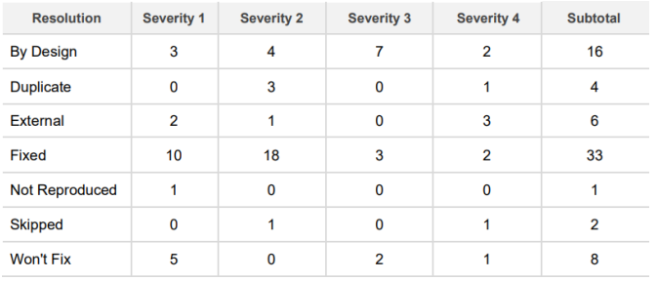

**RESULTS:**

**Performance Metrics :**

The performance of the website varies based on the software chosen for implementation. Built upon NodeJS, a light, and high-performance engine, NodeRED is capable of handling up to 10,000requests per second. Moreover, since the system is horizontally scalable, an even higher demand of customers can be served.

**ADVANTAGES & DISADVANTAGES:**

**ADVANTAGES:**

* Lower battery consumption since processing is done mostly by Node-RED servers in the cloud
* Cheaper and low-requirement microcontrollers can be used since processing requirements are reduced.
* Longer lasting systems.
* Dynamic Sign updating.
* School/Hospital Zone alerts

**DISADVANTAGES:**

* The size of the display determines the requirement of the microcontroller.
* Dependent on OpenWeatherAPI and hence the speed reduction is the same for a large area in the scale of cities

**CONCLUSION:**

Our project is capable of serving as a replacement for static signs for a comparatively lower cost and can be implemented in the very near future. This will help reduce a lot of accidents and traffics and maintain a peaceful environment.

**FUTURE SCOPE:**

The introduction of intelligent road sign groups in real-life scenarios could have a great impact on increasing driving safety by providing the end-user with the most accurate information regarding the current road and traffic conditions. Even displaying the information of a suggested driving speed and road surface condition (temperature, icy, wet, or dry surface) could result in smoother traffic flows and, what is more important, in increasing a driver’s awareness of the road situation.

**APPENDIX:**

**Source Code:**

**PYTHON CODE :**

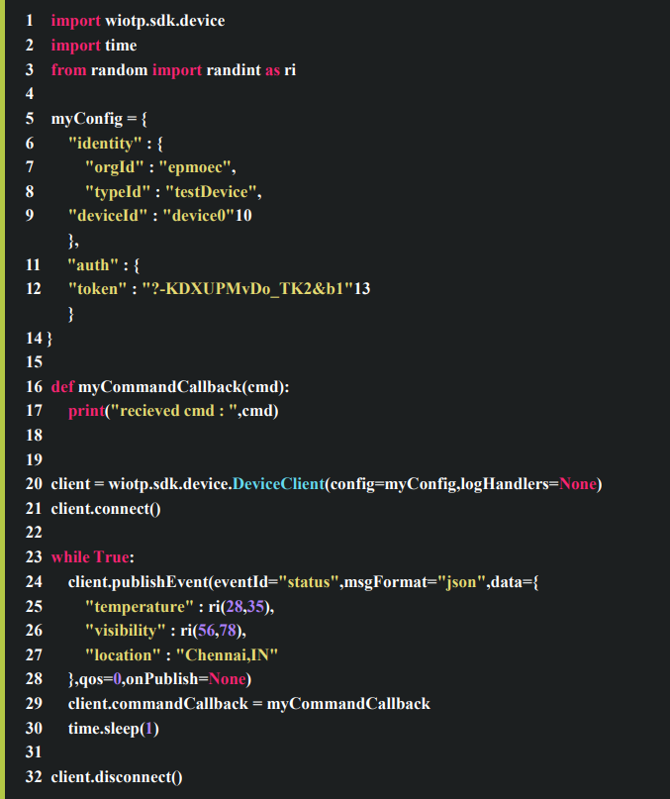

This code is used to send data to cloud

**OUTPUT :**

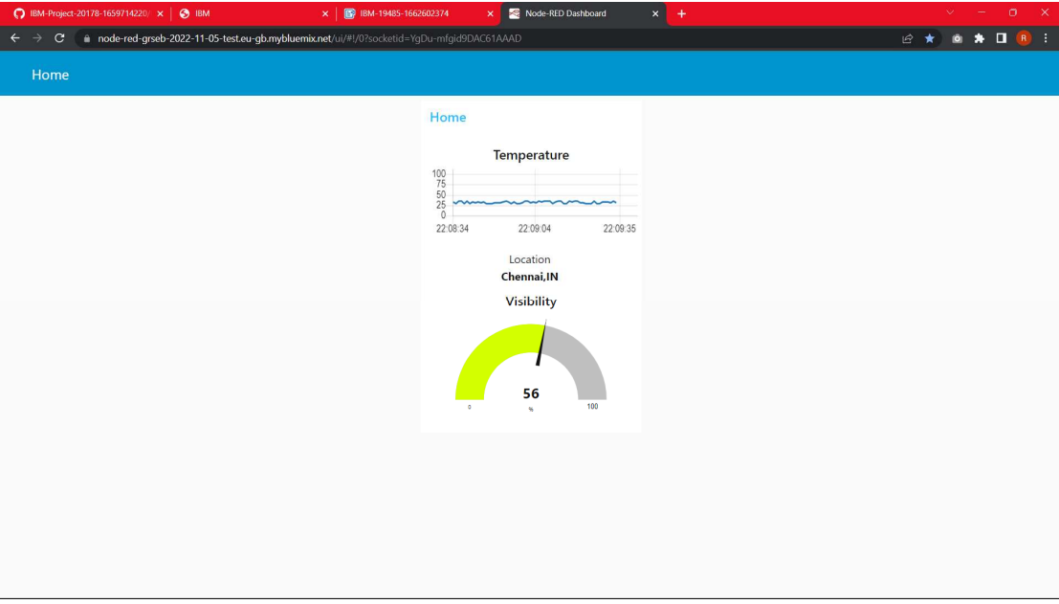

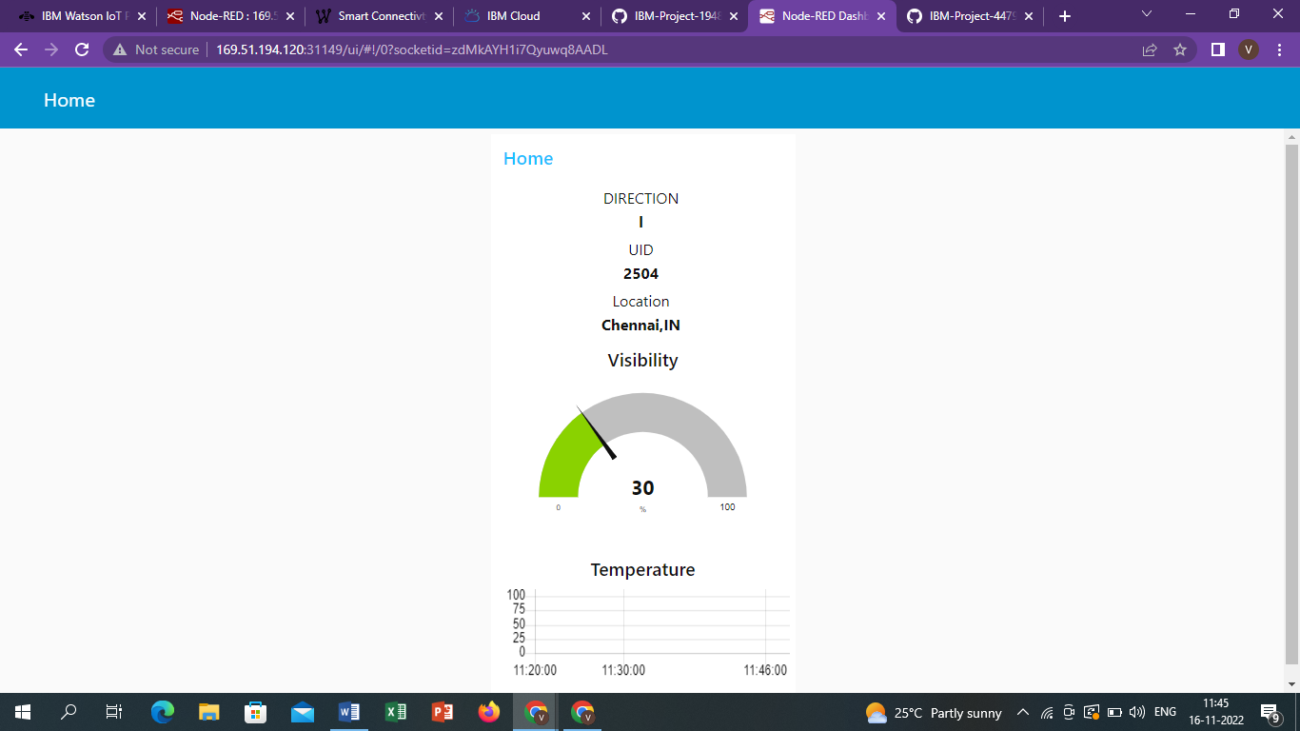

**GitHub & Project Demo Link:**

GitHub link -<https://github.com/IBM-EPBL/IBM-Project-12454-1659451784>

Final Video Link-<https://drive.google.com/file/d/16fGY0RCn1ScSrAQj9Leu3jBCql8vF8p5/view?usp=sharing>